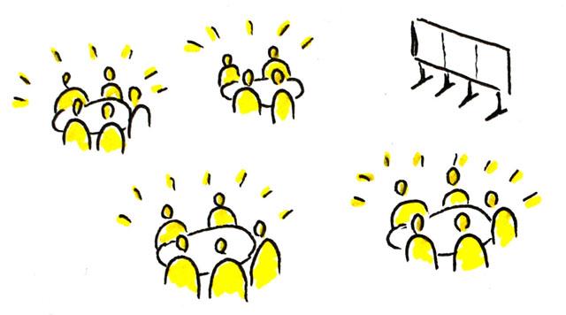

Over the past few years, in classrooms, various meetings, and all-college forums, Grossmont College has discussed student outcomes data, completed surveys on student engagement, and conducted student focus groups.

Based on these many discussions and a recent review of those same data by a college workgroup (as part of our participation in the Achieving the Dream Initiative [ATD]) three primary areas of focus related to student success rose to the top:

For Course Completion:

* Professional development

(in-classroom strategies)

* Mentoring
* Supplemental Instruction
* Early alert

For Basic Skills Sequence Completion:

* High school – college curriculum alignment
* Course acceleration

For Student Engagement:

* Professional development
* Mentoring

In order to most effectively impact these measures in a positive way, we need to throw our collective efforts behind the implementation of a few targeted, **research-based, high-impact** practices that can affect the success of larger numbers of students.

These include:

DRAFT

Fall 2015

## Getting Involved

What's Next?

Based on common elements of the college student success plans (Basic Skills, Student Success & Support Program, and Student Equity) and our Title V grant, the results of the World Café event, and data review, the ATD workgroup is recommending the following three best practices for broad implementation over the next year:

* Student Engagement Practices
* Course Acceleration
* Supplemental Instruction

SHARE YOUR THOUGHTS

To share your thoughts on these recommendations or for more information, contact:

Lida.Rafia@gcccd.edu x7770

In September 2015, approximately 80 Grossmont College faculty, staff, administrators, and students participated in a robust "World Café" conversation on student success. The purpose of the conversation was to allow time for participants to: 1) contribute their thinking and experience; 2) listen and understand others; and 3) connect ideas for student success. Following the event, the ATD workgroup compiled the themes as follows:

* **Engagement/college connection matters** – inside and outside the classroom
* **Meeting the needs of students and empowering them**
* **Course acceleration needed** – for basic skills sequence completion
* **Need intrusive counseling**
* **Embedded tutoring/supplemental instruction** – for basic skills and targeted classes
* **Professional Development for faculty and staff** – student engagement, equity pedagogy

Equity Gaps in Successful Course Completion

(ATD first-time cohort data)

Race/Ethnicity (top three enrolled groups)

White – 75%

Hispanic Latino – 65%

African American/Black – 56%

Gender

Female – 71%

Male – 69%

Foster Youth – 60%

(compared to non FY @ 70%)

Age

30-49 years – 77% 20-24 years – 67%

25-29 years – 72% < 20 years – 70%

Completion of Basic Skills Sequence

(complete transfer course within three years)

(ATD first-time cohort data)

English

Overall – 35%

ESL

Overall – 63%*

Math

Overall – 14%

NOTE: Approx. 75% of first-time students assess at below transfer level in English and/or math.

* - Student Success Scorecard data

What we know

Student Engagement

**What's going well** (CCSSE data)

* 59% of students reported asking questions in class
* 70% reported they analyzed basic elements of idea, experience, or theory

**What's not:** (faculty vs. student answers)

Students: Faculty Student

* Ask questions 87% 59%
* Referred to tutoring 46% 10%
* Work with other

students outside class 63% 38%

Achieving the Dream – Impacting Student Success

**What can we do?**